What Students Will Learn

Learn How to Configure (set up), use & protect Computers | Master Hardware & Keyboarding & Control Panel Items | All about Windows 11 & use the New USF DIT Curriculum  How to do Installs, Upgrades, Maintenance & Troubleshooting  Operating Systems, Administrative Tools, Commands & more
Career Exploration | Career Planning | Create a Digital Portfolio with a resume, cover letter, budget & presentation. School to work application to improve readiness & put you above other candidates for your career interest.
Standards Mastery in Software Applications  & USF DIT Course Curriculum | Microsoft Office Suite | 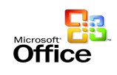  Gain proficiency using Word, PowerPoint & Excel  all relevant to school & future employment!
  CERTIFICATION | Word Press | Become an expert on how to use an open-sourced software content management system. Create websites, blogs & everything in between & acquire this certification recognized by professionals.
PREPARE NOW  & APPLY for Countryside High’s Prestigious ISTEM PROGRAM  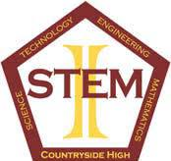 | Set yourself above the competition in IT fields as you gain Skill, Knowledge & Pass recognized Industry Certifications. | COMPLETE THE PREREQUISITE NOW, SO YOU CAN APPLY TO THE ISTEM PROGRAM AND DELCARE YOUR CHOICE OF YOUR ISTEM MAJOR(S).  - Biotechnology  - Computer Systems & Information Technology (CSIT)  - Communication Technology (Comm Tech)  - Cybersecurity  - Digital Design  - Engineering  - Gaming & Simulation  - Web App Programming & Development  - Wood Technology & Construction Design
Get ready for a year of learning as you master Windows 11, Computer Operating Systems, create your Digital Portfolio with Microsoft Word, Excel & PowerPoint program tools. Master Word Press & pass this valued industry certification.
This course is the prerequisite to enter the ISTEM program.
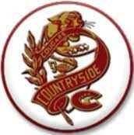
DIGITAL INFORMATION
TECHNOLOGY

